Description of the UDP Calculator
The UDP Calculator takes the user input for two numbers and an operator from the choice of adding, subtracting, dividing and multiplying , it then does a validation check on the users inputs for the two number values, afterwards it sends the data to the server and does the calculation on the server once the final answer has been deduced it is sent back over to the user and displayed. This meets the aim I have been given as it takes user input for the numbers and what calculation they would like to do and does the calculation on the server and sends it back to the user all through UDP Communication.
What libraries I used and how
I used the socket library so I could create the server, the client and the ports that are able to connect them together with the built-in functions that come with the socket library
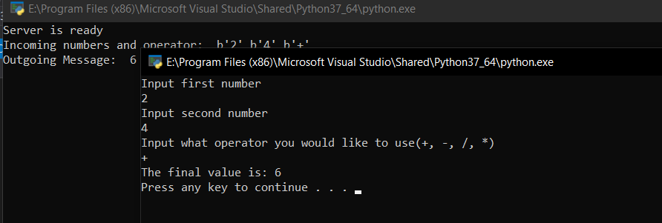
My Evidence of it working

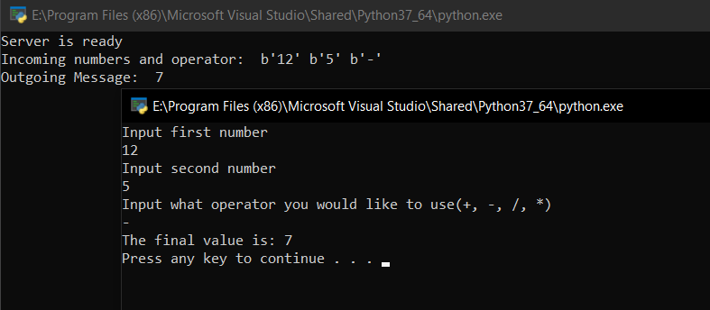

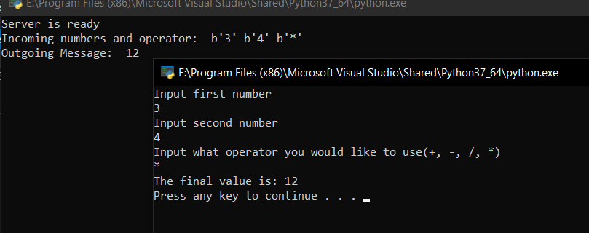

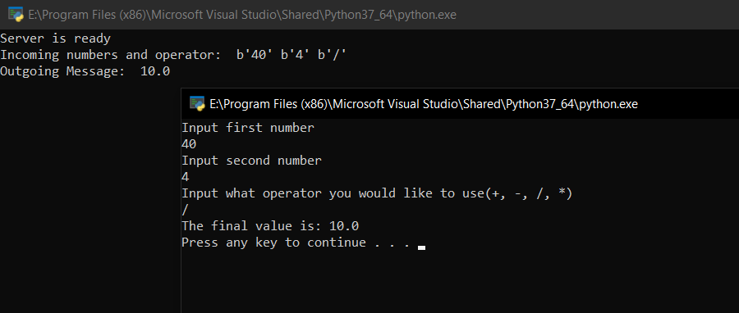

Description of the TCP Document Reader
The Document reader takes the Document that has been given to it and opens and reads it into a variable, it then sends it to the server so it can check how many characters it has – Including Whitespace – and how many words it has in it, with this data it then sends it back to the client and prints the number of words and characters on the clients display so they can see it. This fulfils the aim I was given as the client uploads the contents of a text file to the server and the server sends back the number of characters and words in the file
What libraries I have used and how
I used the socket library so I could create the server, the client and the ports that are able to connect them together with the built-in functions that allowed me to set up the TCP Connection
My evidence of it working
